ENGLISH (EN)

Cadre Training Manual

Contents

Introduction 2
Role and Structure of the Cadre 3
Cadre Registration and Membership 6
Cadre Responsibilities by Assignment 8
Rotary Grants Advising: What Every Cadre Member Should Know 12
Cadre Site Visit Protocol 17
Site Visit Process: Preparation and Logistics 22
Cadre Promotion……………………………………………………………………………………………………………………………………25
Appendix/Resource Library 27

Welcome Message

We are delighted that you have registered to serve in The Rotary Foundation Cadre of Technical Advisers. This training manual outlines the roles and responsibilities of Cadre members and provides important information about how Cadre members support Rotary grants. Cadre members play an invaluable role in helping Rotary members in both the planning of stronger projects and the monitoring of grant efforts our Foundation is funding. On behalf of the Trustees of The Rotary Foundation, I welcome you to the Cadre. I look forward to working with you as we assist our fellow Rotary members with their grants.
Trustee Marcelo Demétrio Haick, Cadre Chair 2021-24
Past District Governor, Carolyn Johnson, Vice Chair 2021-24
How to use this manual

Use this manual to familiarize yourself with the structure of the Cadre and your responsibilities as a Cadre member, and to assess and improve your knowledge of how to serve Rotary members and The Rotary Foundation (TRF).

Throughout the manual are hyperlinks to additional resources. A list of Rotary and non-Rotary resources is also available in the appendix. You should familiarize yourself with the resources so you can easily reference them when needed and make appropriate recommendations to Rotary members seeking assistance.

Role and Structure of the Cadre

Overview

Cadre Mission Statement
The Rotary Foundation Cadre of Technical Advisers strengthens the impact of Rotary’s grants by safeguarding Foundation funds and assisting Rotary members in planning projects.

What is the Cadre?
The Cadre is a group of volunteer Rotary members from around the world who possess technical and professional expertise in one or more of Rotary’s seven areas of focus or auditing and are familiar with the grant program.

Purpose of the Cadre
The Cadre fulfills its mission by
• Providing assistance and advice to Rotary members who are planning and implementing projects
• Assisting the Trustees with the grant funding process by reviewing grant applications for proposed projects
• Evaluating the implementation of projects that have received Foundation grant funds to ensure that grant funds are being used in accordance with the Terms and Conditions for Rotary Foundation Global Grants and District Grants and that stewardship guidelines are followed

Requirements for Cadre Membership
As of 1 July 2021, to be a registered member of the Cadre, a Rotary member must meet the following qualifications:
- Be a current, active member of a functioning Rotary club
- Be in good standing with The Rotary Foundation and Rotary International
- Have significant experience planning and implementing Rotary grants
- Have two years of professional experience in one of the seven areas of focus or financial auditing
- Complete the Cadre member orientation process
- Update registration with the Cadre every three years

Expectations of Cadre Members
Whether on an official Rotary assignment or advising Rotary members in your district on how to plan a global grant, keep the following points in mind:

- Know your expertise and your limitations.
  - Only accept official assignments or take on requests for project planning advice if you are comfortable with the project type and have adequate time in your schedule.
- Promote sustainability.
  - Discuss the many benefits of community assessments.
  - Outline how Rotary members can maintain an active role in the project, effectively manage grant funds, and raise Rotary awareness at the project site and in their community.
- Be a resource.
  - Understand Rotary grants requirements and the grant application system, and have a strong familiarity with the global grant resources available.
- Be positive.
  - Do your best to offer encouragement and guidance to Rotary members planning global grants, but also acknowledge that it is OK to make mistakes and urge Rotary members to share lessons learned.
- Seek help and collaborate.
  - Reach out to your Cadre Leadership who can provide guidance and connect you with other Cadre members.

Roles of Cadre Members
The Cadre is composed of technical advisers, technical coordinators, regional organizers, and the Cadre chair and vice chair. However, all registrants are commonly referred to as Cadre members.

Technical Advisers
All Cadre members are considered technical advisers.

Technical Coordinators
There are three technical coordinators for each area of focus and financial auditing. They are appointed each year by the trustee chair-elect to serve three-year terms.

Technical coordinators have extensive technical or development experience, as well as strong familiarity with the Cadre and Foundation programs. They serve as leaders and mentors to Cadre members and consult with Foundation staff as needed on projects within their area of expertise. Key responsibilities include:
- Collaborating with Cadre leaders and advisers, Rotary staff, and other project planning resources to increase the impact of Rotary’s grants
- Communicating with the Cadre members on their teams
- Advising Rotary members who are planning projects and implementing grants
- Reporting the progress their team is making towards achieving annual goals
Regional Organizers

Regional organizers are current or past Cadre Technical Coordinators who are appointed by the Cadre chair to lead the following seven geographic regions for the Cadre program: Mexico, Central America, South America, and the Spanish-speaking Caribbean; East Asia; Europe, the Middle East, North Africa, and Central Asia; United States, Canada, and the English-speaking Caribbean; South Asia; South Pacific (the Philippines, Indonesia, Australia, and New Zealand); and Sub-Saharan Africa.

Regional organizers are expected to raise the awareness of the Cadre program and expand the use of Cadre members as a project planning resource. Regional organizers achieve this by helping to build relationships between the Cadre advisers living within their region and between the Cadre program and club, district, and regional leaders. Key responsibilities include:
- Organizing the efforts of advisers living in their region, including all areas of technical expertise, to increase the project planning assistance available to clubs and districts
- Motivating Cadre members to take action at the club and district levels and expanding engagement pathways
- Building regional connections between the Cadre program and Rotary’s district and regional leaders
- Reporting the progress their team is making achieving annual goals
Cadre Chair and Vice Chair
The trustee chair-elect appoints a Cadre chair and vice chair to serve three-year terms as consultants to the Stewardship Committee of the Trustees. Key responsibilities include:
- Training and supporting technical coordinators and regional organizers
- Reviewing Cadre assignments
- Ensuring quality, integrity, and consistency of Cadre evaluations
- Serving as consultant to the Stewardship Committee of the Trustees
- Assist with Cadre training seminars and special initiatives
Identifying project trends and concerns and providing recommendations and best practices to share with stewardship staff

Role of Rotary Staff
The Foundation staff who work closely with Cadre members include Cadre staff, stewardship staff, and regional grants officers.

Cadre Staff
The Stewardship specialists and Stewardship supervisor act as liaisons between Cadre members, Rotary grants staff, and the trustees. Key responsibilities include:
- Assisting with the recruitment, registration, membership retention and orientation of new Cadre members and the maintenance of the Cadre membership database
- Facilitating the Cadre assignment process
- Developing and conducting training for Cadre members on monitoring and evaluation techniques, sustainability principles, and other valuable assessment methods

Auditing, Monitoring, and District Support Specialists
As part of Rotary’s stewardship team, the auditing, monitoring, and district support specialists work with the Cadre’s financial auditors in maintaining proper stewardship of Rotary grant funds.

Regional Grants Officers
Regional grants officers support Rotary members in designing sustainable and high-impact grant projects that address Rotary’s areas of focus. They are the project sponsors’ primary point of contact with the Foundation, processing grant applications for projects in a given geographical area. Officers review Cadre evaluations, may communicate directly with the Cadre members regarding project specifics, and discuss the results of Cadre evaluations with the project sponsors as appropriate.

Area of Focus Managers
Area of focus managers oversee the grant activity within each of the Foundation’s areas of focus. They consult with Rotary members on project design and area of focus policies and guidelines and may liaise directly with Cadre members.

Role of Rotary Foundation Board of Trustees
To make informed decisions about project funding and grant policies, the Trustees consider Cadre evaluations as they review grant applications and programmatic issues. Two Foundation committees work directly with the Cadre and use its expertise:

Programs Committee
The Programs Committee makes policy decisions for the grants program and performs reviews of all Cadre advance site visit evaluations in order to provide funding recommendations to the Trustees.

Stewardship Committee
The Stewardship Committee makes recommendations to the Trustees on all matters related to stewardship, compliance, oversight, and fiduciary responsibility. This includes imposing sanctions, setting policy, and advising the general secretary on investigations, audits, and legal action.

History of the Cadre
The Trustees recommended the formation of the Humanitarian Grants Cadre of Technical Advisers in 1995, recognizing the need to provide more oversight and technical assistance to Rotary members who undertake substantial and complex projects. The group provided a way to harness the resources of qualified Rotary members to help evaluate and assist with technical aspects of the former Health, Hunger and Humanity (3-H) Grants.

In 2001, the Trustees expanded the scope of the Cadre by recommending that it also review competitive Matching Grants. At that time, technical areas were created to correspond with project expertise and financial auditing. To reflect the new grant model under the Future Vision Plan, the group is now known as The Rotary Foundation Cadre of Technical Advisers.

Under the leadership of Past RI Director and Cadre Chair Phil Silvers (2014-18), an emphasis was placed on having Cadre members actively assist Rotary members with project planning to produce more comprehensive and sustainable grant applications prior to submission to the Foundation.

Cadre Registration and Membership

Cadre Registry
A Rotary member who applies for Cadre membership is placed on the Cadre registry. Cadre staff use the registry to facilitate the Cadre assignment selection process and advising services, and to send Cadre-related correspondence. Over 500 Rotary members belong to the Cadre registry, including current and past RI directors and Foundation trustees.

Cadre Registration Process
- Interested applicants should navigate to the Cadre My Rotary webpage to apply. The applicant should possess professional skills and have direct professional experience in one or more areas of focus or financial auditing. Cadre staff perform a review of the applicant’s credentials.
- Cadre must complete the Grant Management Seminar and Advising Planners of Rotary Grants courses in the Rotary Learning Center within 30 days of submitting an application.
- The applicant’s district governor, district Rotary Foundation chair, and district grants subcommittee and stewardship chairs, as well as club president, are notified of the applicant’s desire to join the Cadre. If no objections are heard, the application moves forward and Cadre leadership is notified. Once the applicant is registered, the Cadre member’s contact information may be shared with Rotary members looking for project planning and implementation assistance.

Privacy is important to Rotary and any personal data you share will only be used for official Rotary business. For further information about how Rotary uses your personal data, review Rotary’s Privacy Policy or contact privacy@rotary.org.

Cadre Learning Courses
Rotary members registering for Cadre membership are asked to complete the following e-learning courses within 30 days of application submission:
- Grant Management Seminar – all courses included in this learning plan need to be completed.
- Advising Planners of Rotary Grants

Cadre Renewal
Cadre memberships are automatically renewed every three years to ensure that Rotary’s records accurately reflect Cadre members’ skills, expertise, and availability. If you do not wish to renew your Cadre membership, please notify Cadre staff at cadre@rotary.org.

Ensure your most recent résumé or curriculum vitae is uploaded to your Cadre profile. Upon renewal you may be asked to review new materials or complete new courses.

Training Opportunities
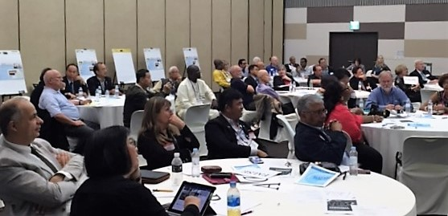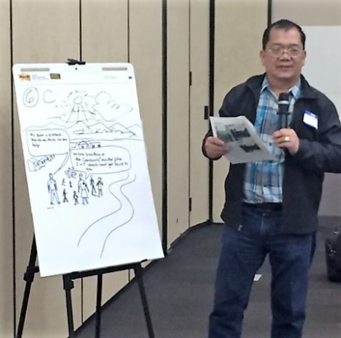

Cadre training at the 2016 Rotary Convention in Seoul, Korea

Annual training is conducted in advance of each Rotary International Convention. Trainings focus on:
- Strengthening understanding of global grant requirements and policy
- Advising techniques
- Elements of sustainable projects
- Approaches to monitoring and evaluation, such as analysis of case studies, project scenarios, and grant examples
These events offer an opportunity for Cadre members to network, work in small groups, and learn from one another in a participatory environment. Webinars, regional Cadre trainings, and other promotional events are scheduled periodically and announced on Microsoft Teams.

Microsoft Teams

The Cadre uses Microsoft Teams to collaborate and share knowledge. Once your Cadre application is approved, you will receive an e-mail invitation from Microsoft Teams to join the TRF Cadre group. Download the Microsoft Teams application for desktops or mobile devices for the best experience.

Notify cadre@rotary.org once you have accepted the Microsoft Teams invitation and you will be added to the relevant technical sector and geographic region channels for collaboration.

Cadre Long Term Plan (2020-2022)
The Cadre’s Long Term Plan has been designed by Cadre leaders and Cadre staff to improve the effectiveness and usefulness of the Cadre program and strategically guide the Cadre’s efforts into the future.

Its priorities and objectives are to:

- Clarify our Structure
- Enable active and purposeful engagement
- Improve Communication

Cadre Responsibilities by Assignment

Cadre Assignments
When Cadre members provide guidance on global grant planning and implementation, the result is often high-quality, sustainable projects. Cadre advice and oversight helps to maximize the impact of Rotary’s projects and ensures that contributions to the Foundation are used responsibly.

Project Planning Assistance
“In my opinion, the best thing Rotary has done to enhance the grant writing process is to have expert Cadre members to review the grant application.”
— PDG Paul C. Roberts, D-6150 (USA)

Cadre members with significant technical expertise in an area of focus, especially those with experience implementing Rotary grants, are encouraged to assist fellow Rotary members in planning global grant applications. Such assistance will ideally take place at the local level. Cadre members from the same area are more likely to understand cultural, socioeconomic, and political contexts in which the project is being planned. That said, there are also instances when it is appropriate for Cadre members from outside the district to give advice and insights to Rotary members planning a project. This remote advising can be done easily through email, online communication platforms, or phone conversations.

Cadre advisers should encourage Rotary members to complete a comprehensive assessment of the community they plan to work with at the beginning of any project planning. Community assessments are covered in more detail in Community Assessment Tools.

Provide guidance on best practices and help Rotary members and community members identify appropriate project objectives. If you have a background in monitoring and evaluation, assist the host sponsors with developing a monitoring and evaluation plan and explain the importance of this practice. Monitoring and evaluation plans increase the likelihood of achieving sustainable results and overcoming obstacles in a timely manner. Even if you do not have a background in monitoring and evaluation, you can stress its importance to the sponsors and encourage them to ask their Foundation staff contact for guidance.
- Encourage Rotary members to perform an environmental scan to determine what other projects are taking place in the region. This prevents project overlap or duplication and provides an opportunity to partner with organizations or other Rotary clubs already working toward mutual objectives.
- Encourage strong partnerships between host and international sponsors. Active participation from local clubs is critical, as projects led from afar can be difficult to implement and monitor and tend to have lower success rates.
- Recommend that Rotary members purchase equipment and technology from local sources whenever possible. This promotes sustainability and contributes to the local economy.
- Encourage Rotary members to develop an in-depth financial management plan to ensure project activity costs can be supported by the community after the Rotary project ends.
- Encourage Rotary members to explore the possibility of partnering with a cooperating organization that has demonstrated success in the relevant area of focus or project site.

Site Visits and Audits
Cadre members may be asked to conduct technical reviews, site visits, and audits.

Notes about conflicts of interest and confidentiality
When invited to perform an official Cadre assignment, Cadre members need to maintain strict objectivity. In order to avoid conflicts of interest, Cadre members are never assigned to a review a global grant that is sponsored by the district in which they reside (exceptions are commonly made for multi-country districts). Cadre members should not accept an invitation from Rotary to review a project that involves any individuals with whom they hold a personal or business relationship (i.e., family members or business partners) and Cadre members should not take on reviews of projects that they have been personally involved in planning or executing. If there is any question or doubt, please contact the Stewardship Specialist for clarification on this policy.

Audits and evaluations submitted by Cadre members may contain confidential information, such as personal data of individuals (grant recipients, Rotary members, etc.) and should be handled in accordance with Rotary’s Data Use Policy.

It is important to share knowledge learned on-site, and Cadre members are encouraged to incorporate real examples of project failures and successes into any training or guidance they might provide to other Cadre members or Rotary members. When sharing site visit experiences, please refrain from using specific grant numbers or project identifiers such as the exact location of a project site or names of project sponsors or clubs.

Cadre Assignment Selection Criteria
The Cadre assignment selection process weighs multiple factors. Preference is given to Cadre members who best meet the following criteria:

- Professional experience — Appropriate background and technical expertise that matches the project type
- Language skills — Ability to communicate in the language spoken by the host Rotary members and preferably the project’s beneficiaries
- Rotary grant experience — Strong familiarity with and understanding of the Rotary grants program and what makes a grant project successful
- Geographic location — Proximity to the project site. While Cadre members are never selected to review grant projects hosted by their own district, the Foundation attempts to send Cadre members to visit projects within their geographic region whenever possible. This reduces costs and travel times associated with site visits.
- Cultural familiarity — Previous experiences working in the project region and an understanding of cultural norm and traditions
- Quality of previous Cadre evaluations — For Cadre members who have previously completed an assignment, a history of submitting high-quality evaluations within the requested time frame

Cadre member Dr. Dennis Addo (right) of D-9102 (Ghana) examines an X-ray during a site visit in India.

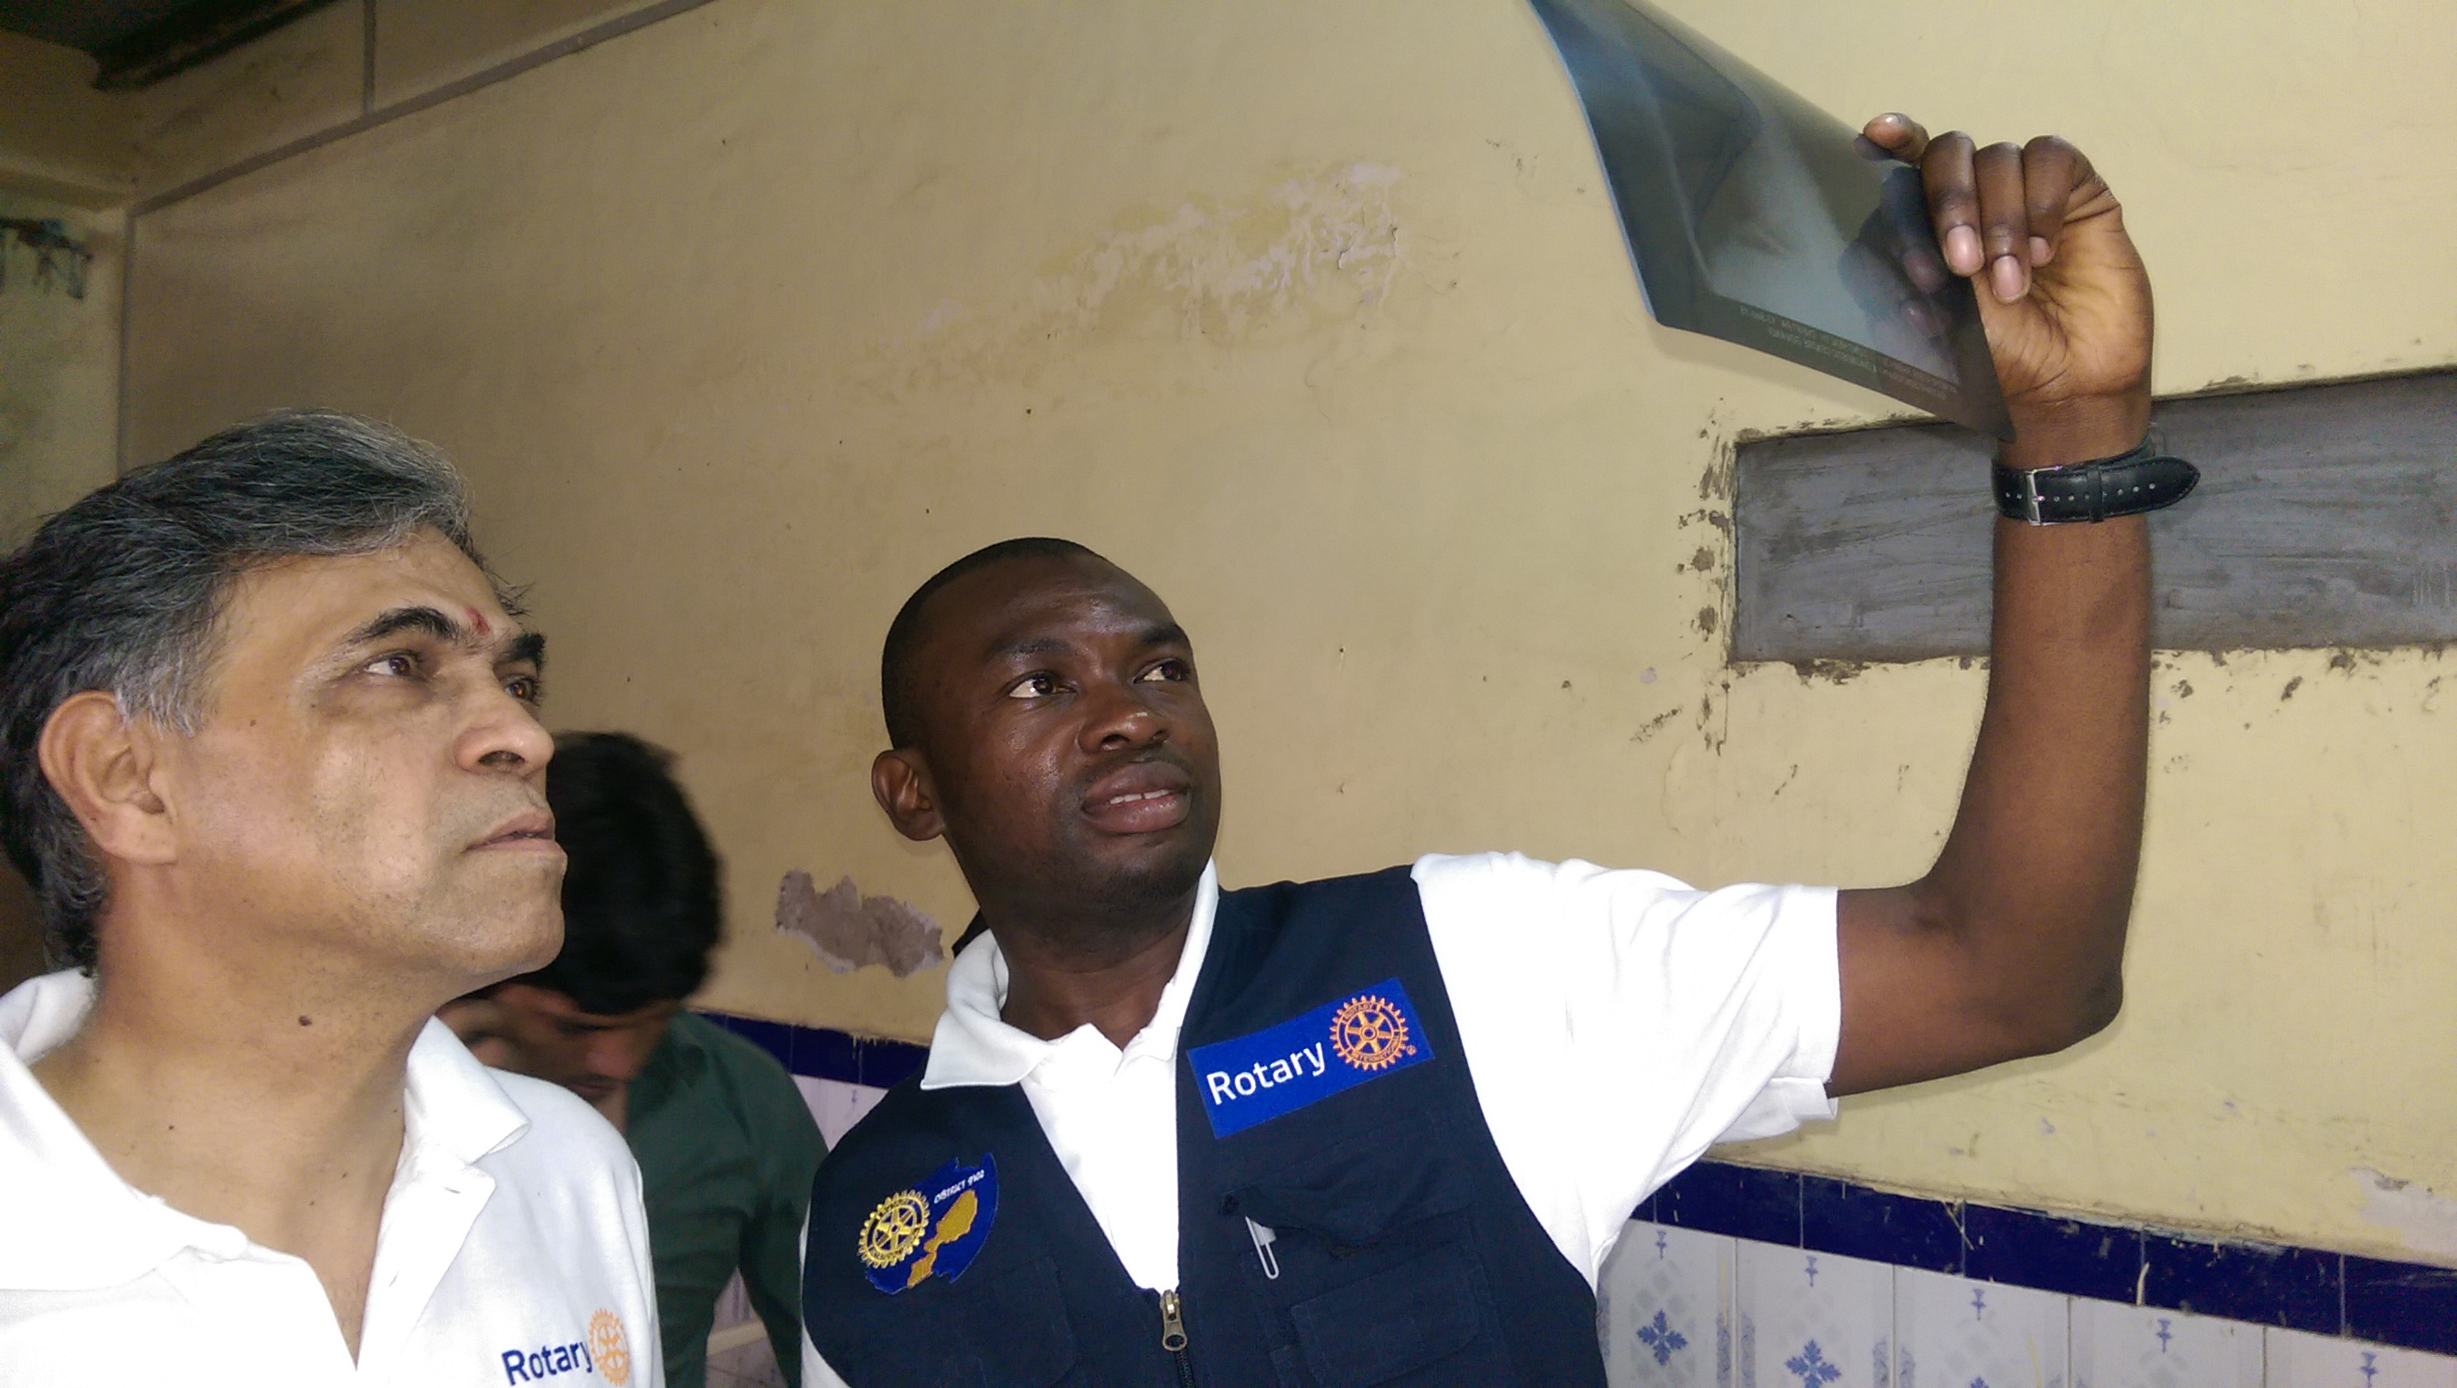
Site Visits
The Foundation covers travel costs, travel insurance, and related expenses for site visits. Details are provided on Rotary’s Travel & Expense webpage and in Rotary’s travel and expense policy, which must be reviewed before accepting a site visit invitation As a steward of Foundation funds, please be mindful of expenses while serving on Cadre assignments.

Site visits and audits are generally three days in length and provide an opportunity for the Cadre member to collect information through visual inspection and by meeting with the sponsoring Rotary members, beneficiaries, cooperating organizations, and other stakeholders involved in the project’s implementation.

Advance Site Visits
Global grant applications for projects requesting between $200,001 and $400,000 from the World Fund receive an advance site visit to evaluate the quality, feasibility, and likelihood for sustainability of the proposed project (effective 1 July 2019). These visits take place before a project is approved by the Foundation and the evaluations submitted by the Cadre site visitor are considered in the funding decision by the Trustees.

Interim Monitor Site Visits
Global grant applications that are approved and receive between $50,001 and $200,000 from the World Fund will receive an interim site visit about halfway through the project (effective 1 July 2019). The interim monitor evaluates the project’s implementation progress, acknowledges strengths, addresses any challenges, and offers suggestions for course correction, if necessary.

Occasionally a project will complete implementation before the required interim monitor visit can be arranged. In these instances, the Cadre member will complete a post-project site visit to evaluate the effectiveness and sustainability of the project and assess how it will continue to benefit the target population now that Rotary grant funding has ceased.

A note about vocational training teams: Cadre members will review and visit global grants that incorporate vocational training teams into humanitarian projects and receive more than $50,001 from the World Fund. When evaluating a project that includes a vocational training team, it’s best to arrange your travel so that it coincides with a team trip to the project site so that you can observe skills-building firsthand. Learn more about vocational training teams.

Grant Model Evaluation Assignments
The Trustees continue to assess how Rotary clubs and districts have adopted the Rotary grants model in order to determine whether adjustments need to be made to the program. Experienced Cadre members may be called upon to assist with Grant Model Evaluation efforts. These site visits require specialized training and selected Cadre members work with Rotary’s Research and Evaluation team to prepare and execute assignments.

Audits
Cadre financial auditors travel to the site of approved grant projects to review financial records, assess the management of grant funds, verify assets and confirm that grant funds were expended as approved, and evaluate the overall project implementation. If the financial management of the grant needs improvement, auditors are asked to help the sponsors find ways to accomplish this. Cadre auditors may be asked to conduct the following types of audits:
- Routine audits — Routine audits may be conducted on global grants that receive more than $200,001 from the World Fund in lieu of the required interim monitor site visit.
- Random audits — Each year, the Stewardship Department randomly selects a small percentage of global grant projects to be audited.
- Targeted audits — The Stewardship Department conducts targeted audits when concerns are raised about the potential misuse of Rotary grant funds.

Rotary Grants Advising: What every cadre member should know

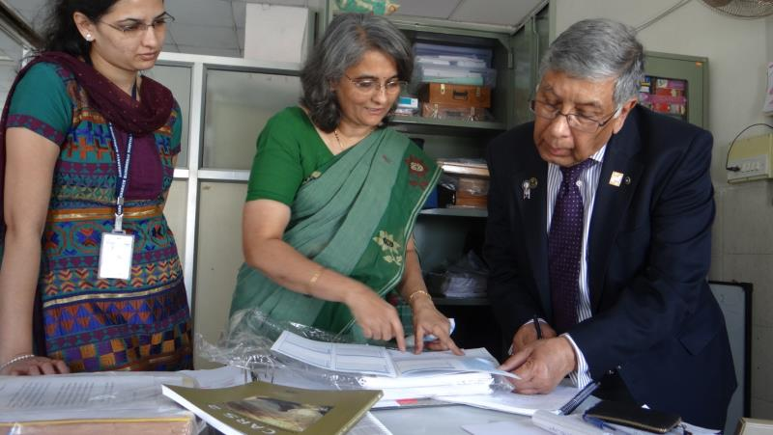

Cadre member PDG Himansu Basu (right) of D-1120 (England) looks over grant documentation during a site visit in India.

As a Cadre member, you are encouraged to assist Rotary members in your district with the planning of global grants. In order to do this effectively, Cadre members must be aware of global grant requirements and best practices.

Community Assessments

Clubs considering applying for a global grant should focus their planning efforts on a community-centered approach to enhance the quality of the project. As explained by longtime Cadre member PDG Francis “Tusu” Tusubira of D-9211 (Uganda):
Rotary clubs should work towards instilling a sense of ownership in the community. In my community experience, I have learnt the following key lessons:
- Never think about what we (Rotary members) are doing in the community as “our” project: It is the community’s project.
- Never think or say we are doing a project in the community: We are supporting the community’s efforts.
- And for the above to happen, we must respect and listen to the community.
Our biggest challenge is to change our mindset as [Rotary members] so that we can help communities support themselves.

A community assessment is a systematic method used to determine the strengths, weaknesses, needs, and assets of a community. A thorough assessment maximizes a project’s ability to have a meaningful impact in the community and, as of 1 July 2018, the findings of the community assessment must be included in all global grant applications.

The Importance of Community Assessments
“Community assessments inform about the ‘real needs’ of a population and potential opportunities to develop solutions that fit the local context.” — Cadre member Jean d’Amour Manirere, D-9150 (Rwanda)

Rotarians may view community assessments as an unnecessary step in the global grant application process. Explain that a comprehensive community assessment greatly enhances project quality and sustainability and that many types of assessments can be conducted with minimal funds. Cadre members should encourage the use of the Community Assessment Tools resource and assist Rotarians in the development and execution of comprehensive assessments.

A comprehensive assessment will include:
- Participation of community members from the beginning of project planning
- Availability of local materials
- A thorough scan of other projects taking place in the community and surrounding communities to identify potential project overlap and opportunities to collaborate
- Incorporation of government standards and potential for integration into governmental programs
A comprehensive assessment can lead to the following outcomes:
- Increased awareness by community members of their community’s strengths and weaknesses and how community members can proactively address them
- Expanded opportunities for different community members to voice their opinions
- Increased community motivation, participation, and leadership in the resulting project
- Heightened awareness by community members of Rotary and its purposes
- Data that can be used to support a project application, make decisions, and support funding requests
- Stronger relationships between the community and Rotarian project sponsors
Remember that global grant funds cannot be used to cover the cost of performing community assessments, but clubs can apply for district grant funding for this purpose.

Project Objectives
Measuring a project’s success begins with deciding what the project’s success would look like. What is the project’s objective? An objective is not a statement of project activities, but rather the positive change in the quality of life that the project hopes to achieve. For example, to support peacebuilding in communities, a project may seek to decrease instances of violence in a neighborhood. An objective can also distinguish between a donation to a community and a humanitarian project.

Once the objective is decided, project sponsors can work with community members to determine the best ways to achieve the objective. This process brings beneficiaries, Rotarians, and other stakeholders to a collective understanding of the project, and helps everyone make decisions about project design. If an element does not potentially lead toward the decided objective, then the element does not belong in the project.

For example, if the teachers, students, administrators, and parents from a local school would like to increase student attendance, and there is a suggestion to buy computers for the classrooms, then everyone can ask “Will computers lead to increased attendance?” Perhaps the addition of new computers will lead to a short-term increase in student attendance. But it’s important to also consider addressing more systematic issues, such as teacher training, increased access to clean toilets, or increased hygiene habits to prevent sickness, that may prove more effective at increasing attendance.

Training (Capacity Building)
Training and education are critical components of global grants. These efforts help ensure that beneficiaries have the capacity to meet project objectives. Encourage Rotarians to reference the Training Plan for Global Grants and think about gaps in knowledge that can be filled by a robust training program as well as who in the community should be trained and who is qualified to deliver training.

Areas of Focus
Global grants must align with the goals of at least one of Rotary’s areas of focus. Encourage Rotarians to refer to the Areas of Focus Policy Statements and relevant area of focus guidelines for global grant funding found on My Rotary when initially formulating their project objectives, activities, and scope.

Sustainability
In addition to general fit, global grant humanitarian projects must also adhere to Rotary’s definition of sustainability, which is “providing long-term solutions to community problems that community members themselves can support after the grant funding ends.”

A central element to sustainability is community involvement and leadership in the project from its inception, and beyond the end of Rotary’s involvement. Rotary’s six steps to sustainability are proven and well-known best practices in the world of community and international development. Adhering to them helps maintain Rotary’s reputation as a leader in doing good in the world.

“A sustainable project in any area of focus needs to start with sponsors listening to the intended beneficiaries. Unless we see the world as they see it — with their anxieties, hopes, daily tasks and troubles, and dreams for their children — we risk totally missing our opportunity to do good.” — Past Cadre Chair and Past RI Director Phil Silvers, D-5500 (USA)

Monitoring and Evaluation
Monitoring is the process of collecting and analyzing project data to measure the project’s progress throughout its implementation. Evaluation is the assessment of the project’s adherence to Rotary guidelines, technical feasibility, relevance, impact, and sustainability. Monitoring and evaluation should be built into the project plan and conducted as part of project implementation, regardless of whether the project receives a Cadre visit.

As a Cadre member, you should discuss the monitoring and evaluation plans Rotarians have for their projects. Find out who is responsible for collecting data, what data they are collecting, how they are analyzing it, what they have learned so far, and whether the project has been modified as a result.

A monitoring and evaluation plan creates structure around a project and acts as a guide for Rotarians, beneficiaries, and other stakeholders throughout the life of the project.

Advising Rotarians on Monitoring and Evaluation
Encourage Rotarians to refer to the Global Grant Monitoring and Evaluation Plan Supplement and help them determine which measures are appropriate for their project. When deciding on the project’s measures, it is important to verify that the data the project sponsors plan to measure is available and accessible. Encourage Rotarians to:
- Measure change in the project community.
  - Consider how the project will affect the attitudes and behaviors of community members.
  - Determine if the project will introduce new skills and capabilities.
  - Limit the number of project measures to only the most relevant.
Once project measures are decided, make sure they incorporate a collection of baseline data and a monitoring and reporting schedule, and specify who will perform the monitoring.

Baseline data is an initial measure taken at a recent point before the beginning of project implementation. Baseline data sets a point of reference to which all project data can be compared. Without a baseline, it is very difficult to show project impact or improvement.

A monitoring plan is a schedule of who collects data, where it is collected from, and when and how often data is collected to check on a project’s progress toward its objective. A monitoring plan begins with the collection of the baseline data and establishes when to re-collect data throughout the life of the project. In creating a monitoring plan, think about the following questions:
- Who will conduct the monitoring?
- What tools will be used to collect data? Do these tools already exist, or will someone have to create them?
- Will those conducting the monitoring need training on how to use the collection tool? Do they understand the importance of quality control and the confidentiality of data collected?
- How often will the monitoring take place?
- How much time will be needed to conduct each round of monitoring?
- Will funds be needed for monitors? For data evaluation?
- Are there any ethical considerations? Could the information being collected be considered sensitive within the community? If so, what measures should be taken to guarantee informed consent, respondent confidentiality, and data protection and integrity?
hat up to 10% of a global grant’s budget can be allocated for measurement and evaluation costs.
f a global grant’s budget can be allocated for measurement and evaluation costs.
Remind Rotarians that up to 10% of a global grant’s budget can be allocated for measurement and evaluation costs.

Remind Rotary members that up to 10 percent of a global grant’s budget can be allocated for measurement and evaluation costs.

Eligible resources for monitoring and evaluation in global grants include:
- Contracted labor of a local organization or paying stipends to community members to collect data
- Consulting costs to technical experts to review and validate data
- Purchasing equipment such as phones, GPS equipment, and laptops to monitor activities
- Local travel costs, such as car rental, fuel, and train fare to conduct site visits
- Cost of electronic surveys, and meeting costs for focus groups for evaluation purposes
- Printing costs for manuals and other materials needed for data collection

Collaboration: Together We Accomplish More

Host and International Sponsor Rotary Clubs
Global grants have an increased potential for sustainability and achieving a greater impact when a club collaborates with other clubs or organizations.

To apply for a global grant, two or more Rotary clubs must work together.
- The host sponsor is the partner in or near the community that’s implementing the project.
- The international sponsor works with the host sponsor, but is located outside of the host sponsor’s country
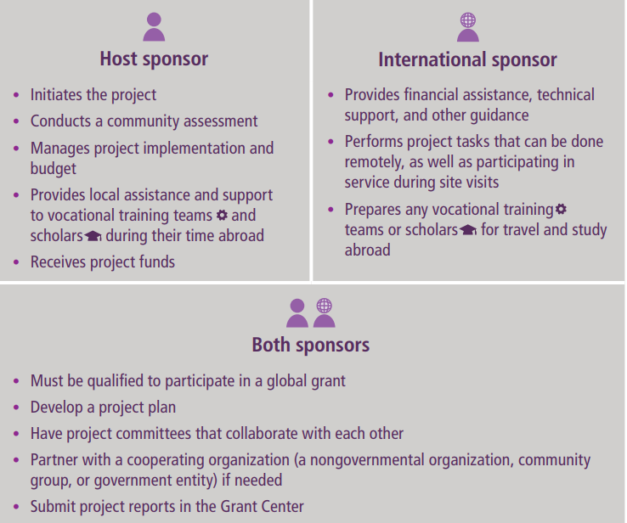

Host and international sponsors have different responsibilities. However, the roles of each sponsor also depend on the clubs involved, the community’s strengths, and the nature of the project. Communication is key. All Rotary sponsors are equally responsible for the success of a global grant-funded project. A successful partnership is one in which roles and responsibilities are clearly defined and each partner attends to its tasks while communicating and collaborating with the others to manage the project.

Other Clubs in the Same District or District-Level Projects
When assisting Rotary members with planning global grants, encourage clubs within a district to work together. Often communities within a district face similar challenges, which can result in different clubs creating similar projects independently. Instead of clubs competing for district funds to undertake similar projects, they could work together to pilot interventions in a few areas, and then scale the project up according to successes seen across time. This collaboration would also mean saving time and funds in identifying community assessment and training tools and other aspects of project planning. The possibility of collaboration between clubs in the same district also points to the importance of a host club playing a strong role in initiating and managing the global grant process.

Collaboration within the same district can also mean an experienced club mentors a newer club to share lessons learned and good practices honed from hosting global grants. Keep in mind that the project committee is responsible for managing the project and grant funds, so the size and scope of the project should not exceed the committee’s ability to oversee and manage project implementation.

Cooperating Organizations
Rotary defines cooperating organizations as any reputable non-Rotary organization or academic institution that provides expertise, infrastructure, advocacy, training, education, or other support to a grant project. Collaborating with a cooperating organization can enhance the quality and effectiveness of a project. For projects that include a cooperating organization, both clubs and the organization must complete a Cooperating Organization Memorandum of Understanding before beginning the project. Although other organizations and volunteers may play a large role, the Rotary members project sponsors are ultimately responsible for the outcome of a project and must take an active role in managing Foundation funds. Grant sponsors, particularly local Rotary members, can take a hands-on role in the development and implementation of community assessments, data collection, and oversight. Steer Rotary members away from situations where the cooperating organization controls and executes all aspects of the project and Rotary’s role is reduced to that of a funder.

Integration (Local Government)
Part of the community assessment should be researching the current government policies and programs as they relate to the project’s overall goal. In planning the project, the host club needs to consider whether the project can be incorporated into the greater infrastructure of the local, regional, or national government. Host sponsors should attempt to integrate their projects into government infrastructure whenever possible to increase the project’s likelihood of sustainability.

Financial Recordkeeping
Sound financial recordkeeping is an important part of planning and implementing a global grant. Make sure Rotary members refer to the financial transparency section in A Guide to Global Grants. Financial management should include the following:
- The host sponsors opening a separate bank account for the project
- Keeping reliable financial records, including bank statements and a project ledger
- Saving all receipts
- Retaining all project documents to comply with the club MOU, local laws, and standard business practices
- Establishing a system to track all inventory, such as equipment and other assets
The financial management plan developed during project planning helps project sponsors keep track of grant funds, promotes transparency, and safeguards against misuse. It also makes reporting easier. The financial management plan is a guide for recordkeeping. Keeping track of finances and overall progress will help Rotary members monitor the budget, evaluate success after the project is completed, and make all project information ready for grant reporting. Make sure everyone involved in the project understands the importance of keeping receipts, storing financial documents, and retaining key project communications.

Cadre Site Visit Protocol
An Opportunity to Assist:
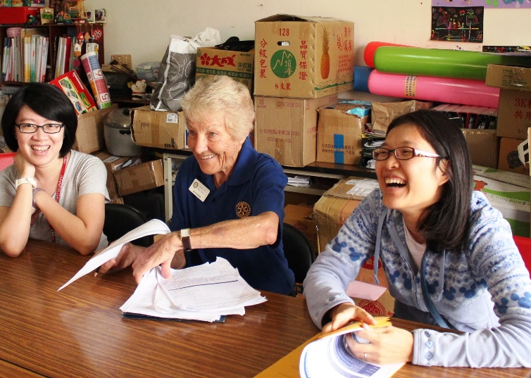

Cadre member PDG Sylvia Byers (center), D-9455 (Australia), during a site visit in Taiwan

It is common for project sponsors to view all Cadre site visits as “audits.” As a Cadre site visitor, we encourage you to inform project sponsors that the primary goal of Cadre visits is to help Rotary members strengthen their projects and to assist the Foundation’s efforts to evaluate and improve the grant program. The best time to discuss recommendations and potential improvements is in person during the site visit and particularly at the site visit feedback meeting. You are encouraged to share your advice and facilitate discussion around how to strengthen the current project. This is an opportunity to share best practices that will also benefit future efforts.

Confidentiality and Ethical Considerations
When collecting data from beneficiaries and stakeholders:

- Make sure you always have the permission of the respondents to ask them questions, and parents’ and/or guardians’ knowledge and permission when meeting with youth (under age 18).
- Ensure the respondents understand why you are asking them questions, and how their responses will be used.
- Clarify that the respondents are not obligated to speak to you and can end their participation at any time without giving a reason and without consequences.
- Remind respondents that there are no correct or incorrect responses.
- If possible, speak to beneficiaries without Rotary members or cooperating organization staff present.
- Have a plan for how you will store the data you collect to guard respondents’ privacy and confidentiality.
- Only ask questions that are relevant to the project.
- Be careful not to create any unrealistic expectations on the part of the respondents. For example, it is unrealistic to promise them a copy of the evaluation results or to suggest that their responses might lead directly to future projects.
- Make sure to find opportunities to talk to a variety of community members and stakeholders. For example, if the project is at a school, try to speak with school teachers and administrators, parents, students, and other community stakeholders.

Photography and Video and Audio Recordings
If you take photographs or video or audio recordings of beneficiaries or other individuals, including Rotary members, at the project site, you must receive the individual’s written permission or the permission of the parent, guardian or legal representative of any individual under age 18 or who lacks legal capacity to 1) take the photograph or recording and 2) use the photograph or recording. You shall ask the beneficiaries or other individuals at the project site who you photograph or record to sign the Rotary International Model Release. Any use of an alternative release must be approved by Rotary International. See the image section of the Rotary’s Privacy Policy for more information about Rotary’s expectations regarding recording the images, voices and stories of individuals.

Site Visit Requirements

Conducting the Site Visit
Use the relevant Cadre evaluation form as a guide and consider these questions:
- Is the project benefiting a population in need?
- Does the project demonstrate elements of sustainability?
- Are Rotary members actively participating?
- Are the grant finances and financial process transparent?
- Is the entire club (or members of the district leadership team, if district sponsored) supporting the project, or is the grant primarily managed by a single Rotary member or small group of Rotary members?
- Is the project technically feasible?

Site Visit Feedback Meeting
All Cadre site visitors are required to hold a site visit feedback meeting at the conclusion of their visit. This meeting provides an opportunity for the Cadre site visitor to summarize the project’s major strengths, challenges, and areas for improvement. The findings should not be surprises to the stakeholders, but rather summaries of discussions you have had with the project sponsors and other stakeholders throughout the visit. You should also use this forum as an opportunity to act as a facilitator in assisting project sponsors, beneficiaries, and other stakeholders to plan next steps.

A summary of the site visit feedback meeting conversation should be shared with all project sponsors. Cadre members are encouraged to review the Site Visit Feedback Meeting instructions. The feedback meeting should be the final step of the site visit and should take place at the end of your visit, prior to departure.

Completing Cadre Evaluation Forms
Consistent, high-quality evaluations enable the Trustees to evaluate and monitor Foundation grant projects effectively. When completing Cadre evaluation forms, please provide clear and detailed responses and ensure that all questions are thoroughly answered and reflect an unbiased assessment of the project.
- Cadre evaluation forms are due within two weeks of returning from the project site.
- Cadre members must submit the official Cadre evaluation form provided at the time of invitation.
- Evaluation forms and all complementary documentation should be submitted online via My Rotary.
  - Submitting evaluations in English will expedite review; however, translation services are available for Cadre members whose strongest language is not English. Cadre members can request a translated version of any Cadre evaluation form (Word document).
- Be specific. Provide concrete examples and detailed responses. Use direct quotes, anecdotes, or stories about the individuals and entities who are involved in the project whenever possible.
- Be objective and candid. Remember that the evaluation will not be shared with the project sponsors.
- Describe the planning advice and recommendations that you shared with the sponsors. Grants staff may endorse or require that your suggestions be followed.
- Take into account the diverse perspectives of all the groups involved with the project.
- Address any areas not covered in the evaluation form that arose during the visit.
- Site visitors are encouraged to upload supporting documentation along with their evaluation, such as:
  - Bank statements that confirm appropriate management of Foundation funds
  - Receipts and invoices for major purchases
  - Any literature or informational pamphlets associated with the project
  - Any other information that would be helpful for Rotary staff and Trustee review
  - Photographs that:
    - Document items and equipment purchased with grant funds
    - Display Rotary signage
    - Show Cadre members and project sponsors in action during the site visit
    - Show beneficiaries engaging with the project

Things to Keep in Mind When Uploading Photographs:
- The appropriate permission from the individual in the photo must have been obtained
- Select a sample of your photographs from the site visit. If you took 50 photos during your visit, try to choose the best 5-10 images to upload with your report.
- Provide a descriptive name for each photo file.

Special Consideration for Auditors
The auditing of global and district grants is an important part of Rotary’s commitment to stewardship. Audits allow the Foundation to ensure that Rotary funds are being used responsibly and that grants are being carried out in accordance with the Terms and Conditions for Rotary Foundation Global Grants and District Grants. In addition, audits improve donor confidence that donations are being used effectively, and give Rotary member grant sponsors the opportunity to receive advice, feedback, and guidance about their projects.

Before Departure. It is important to review both the grant file and the audit form before your departure. Familiarizing yourself with the questions on the audit form will help you to plan your visit and ensure the participation of all necessary stakeholders.

During the Site Visit. Once you arrive at the project site, refer back to the grant file often to get a sense of the project’s progress against its original objectives. A Foundation audit includes a financial review, as well as a review of the project’s overall progress, successes, challenges, and accomplishments. An audit is not complete without a careful review of the project’s progress and impact.

Ensure that your review includes comments on how well Rotary members have implemented the project’s sustainability components. Did the sponsors successfully complete any planned trainings? Are the beneficiaries able to use and maintain the project’s assets? Are measures, such as formation of a Rotary Community Corps, in place to ensure long-term sustainability? Confirming that the project has been implemented fully is equally important to the financial review in completing a Foundation audit.

Finally, the Foundation has specific financial requirements for its grant projects. Sponsors are expected to retain receipts for all project expenses. If receipts are not available, the Foundation will require sponsors to obtain them. Therefore, please review all financial documentation made available by the sponsors, and retain copies of each document for your audit report.

Post Site Visit
Audit evaluations should be completed and submitted along with the relevant supporting documentation within two weeks of your return from the project site. When submitting an audit evaluation, it is important to:
- Answer all questions included in the audit form completely. Each question on the audit form was included by the Foundation to facilitate an understanding of the project as it relates to the unique Rotary grant’s requirements.
- Submit all documents provided to you by the sponsors (receipts, invoices, cash vouchers, etc.). The Foundation will assume that any financial documentation that is not submitted with your report was not made available to you, and will ask the sponsors to provide it.

Site Visit Best Practices

Interviews and Focus Groups
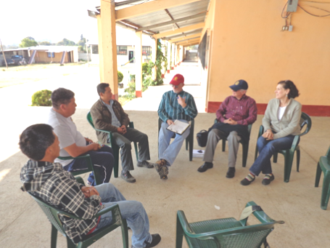

Cadre member William Stumbaugh (third from right) of D-4400 (Ecuador) conducts a focus group during a site visit in Guatemala.

Interviews are individual conversations that may cover any number of topics. Interviews are most appropriate when you want a specific person’s point of view or want to compare points of view of many people without the risk of influencing their opinions.

Focus groups are structured, small group discussions around a few very specific topics. They are most appropriate when trying to get a group’s opinion on a topic.

Select interviewees and focus group participants based on who can best answer your questions while representing the project’s beneficiaries and stakeholders.

Focus groups should generally have five to 10 participants. Participants in a focus group should be similar to each other. Hold different focus groups if there are significant differences in influence between respondents or if a topic might be considered sensitive or embarrassing. This might mean meeting separately with males and females or with employees and their employers.

Ask open-ended questions and encourage examples. Try to ask the same questions to different stakeholders and beneficiaries, as appropriate. A lot can be understood about project challenges and successes from the responses different stakeholders give to the same questions.

“It is critical that you encourage others to talk by listening carefully, using your head, hands, and body to indicate engagement. If some people are not participating, invite and encourage them with questions and physical positioning — looking directly at them, moving closer, and inviting their participation with your eyes and your posture.” — Cadre member William Stumbaugh, D-4400 (Ecuador)

Helpful Hints for Running a Focus Group

- Be organized
- Notify participants well in advance.
- Allow at least 60 minutes for the focus group.
- Prepare your questions in advance.
- Determine whether or not interpretation will be needed and make arrangements if necessary.
- Have participants sign an attendance sheet so there is a record of participants.

- Prepare the location
- Pick a neutral or safe location that is easily accessible, such as a local school or community building.
- Choose a time of day when participants will be available to attend.
- Try to arrange seating in a circle where everyone is easy to hear and no one is left out.
- If possible, provide reasonably priced food or drink.

- Foster a friendly and welcoming environment
- Small talk is critical!
- Make sure to greet participants.
- Allow participants the chance to introduce themselves and interact with each other before the session begins.

- Record the session
- Recording the session and transcribing the discussion later is considered a best practice and allows you to focus on responses and participants instead of taking notes.
- If recording is not an option, do take notes during the conversation.
- Make sure all participants know that you will record the conversation.
- Capture participant names and general demographic information.
- Ensure that notes accurately reflect the flow of the discussion.
- Capture direct quotes if possible.

- Facilitate the discussion
- Begin with a welcome and overview of the session.
- It will help to outline ground rules, such as one person speaks at a time.
- Then get the group thinking with a broad overview question.
- Pause to allow further comments, and probe comments with additional questions, such as “Would you explain further?” or “Can you give an example?”
- Respond to all comments, but redirect questions to the group when possible.
- Be aware of who may not be participating or who may be dominating the conversation.
- Make every effort to include all participants in the discussion.
At the end of the focus group, summarize the discussion, ask for any final comments, and thank everyone for their participation.

If you are interested in learning more about conducting focus groups, contact the Stewardship Specialist for additional training materials.

Site Visit: Preparation and Logistics
Cadre members should use this section to prepare for site visit and audit travel assignments. It is important to understand the process and expectations of Cadre site visitors before undertaking a travel assignment. Much of the documentation referenced in this section is available on rotary.org.

Site Visit Process

1. Cadre staff sends an email message to a Cadre member inviting them to serve as a site visitor.
- The Cadre member must sign in to the Cadre section of the Grant Center in My Rotary to accept or decline the assignment within five calendar days.

2. Review project files and evaluation form.
- Once a site visit invitation is accepted, the Cadre member is provided access to the evaluation form to complete as well as a copy of the grant application and relevant project documentation via the Cadre section of the Grant Center in their My Rotary profile. Each Cadre evaluation form begins with an instructional section that contains guidelines and keys to a successful visit.
- You should review and familiarize yourself with the evaluation form contents before you depart, as you will be responsible for answering each of those questions. The evaluation form along with the project documentation will help you determine what needs to be included in your site visit itinerary.
  - You are highly encouraged to print a copy of your evaluation form and bring it along during your visit for easy reference and notetaking. Keep in mind that your project location may not have Wi-Fi.

3. Schedule site visit and plan itinerary.

- Cadre members will be copied on a site visit notification message to the project sponsors. Cadre members are responsible for initiating communication with the project sponsors to begin discussing potential dates for a site visit and arrange the itinerary. Please remember that site visits are typically three days in length (not including travel days) and the timing of the visit should be convenient for both the Cadre traveler and the project sponsors.
  - Cadre staff understands that for some assignments, three days on-site will not be sufficient. If you believe your assignment warrants more than the standard three days, please contact the Stewardship Specialist.
- Arrange lodging — Ask the host sponsors for recommendations for lodging that is conveniently located, safe, and moderately priced. The Stewardship Specialist will provide you with a nightly budget for lodging upon acceptance of a site visit.

- It is critical to have a detailed itinerary in place before traveling. Cadre members typically work with the host project sponsors to arrange the specifics of the visit, which include:
  - Local transportation arrangements. Have a plan in place for airport transfers and transportation to and from meetings. Local Rotary members are expected to accompany Cadre members to the project sites. Occasionally a 4x4 or special vehicle is required to access remote project locations. If necessary, Cadre members can receive additional funding to cover local transportation costs.
  - Organize meetings with all relevant project stakeholders, including:
    - Host Rotary member committee (attend a club meeting, if possible)
    - Project beneficiaries
    - Community leaders
    - Cooperating organizations (any other organization or government entity involved in the project’s implementation)
  - Schedule a site visit feedback meeting. All Cadre site visitors are required to hold one of these exit interview-style meetings before departing the project site.
  - Ask the host sponsor prior to your visit to arrange for your interviews and focus groups with the individuals and groups you identified.

- To make most effective use of time on-site, Cadre members should schedule virtual meetings, via online communication platforms such as Zoom, before and after arriving to the project site. Virtual meetings should be used to preliminarily collect information, communicate with a broader range of project stakeholders, and contact the international partners to discuss their role in the project.

4. Submit travel request.
- Once your site visit dates have been agreed upon, submit a travel request via My Rotary.
- Requests for international travel should be submitted 24 days in advance of your proposed travel date. Domestic travel requires 16 days of advance notice.
- Please review Rotary’s Travel Policy and remember that:
    - Preapproval from Rotary International Travel Service (RITS) is required for the following travel expenses, including but not limited to:
- All airfare purchases
- Round-trip transportation to airports that exceeds $150
    - If you are driving a personal vehicle, refer to the automobile reimbursement rates.
- Any transportation expense that exceeds $350
- If you are uncertain whether a travel expense needs preapproval, please check with your RITS agent or the Stewardship Specialist.

5. Review travel insurance.
- Review the travel insurance information and print the Travel ID card found on the Cadre Microsoft Teams channel.
6. Expense Reimbursement.
- The Rotary Foundation will no longer provide advanced payments. Cadre members are responsible for paying for the lodging, meals, and incidental expenses associated with their assignment and can request reimbursement upon their return. In addition to meals, lodging, and transportation costs associated with an assignment, pre-departure expenses such as visas, phone calls to project contacts, and required vaccinations are also eligible for reimbursement. Flight costs will be paid for directly by RITS and will not need to be covered upfront by Cadre members.
- In order to be reimbursed, Cadre members must keep a record of all assignment costs and submit an expense report within 30 days of returning home from travel.
- Receipts are required for all lodging expenses and all other expenses that exceed $75. Supporting documentation should also be provided for each expense and should include the amount, date, place, description, and proof of payment.
  - Cadre members from Argentina, Brazil, and India are required to provide receipts for all expenses regardless of amount.
- Travelers will need to submit their expense statements through Rotary’s online expense report system and should review the Expense Reporting Guide and additional resources online.
7. Submit evaluation and send site visit feedback summary.
- Evaluations are due within two weeks of returning from the project site. Please sign in to the online Grant Center through My Rotary and complete your Cadre evaluation online.
  - When completing the evaluation form online, please save your progress frequently. The system does not auto-save and an internet disruption may result in you losing work.
  - Site visit feedback summaries should be sent to the project sponsors via email with copy to Cadre staff and the regional grants officer assigned to the grant before the evaluation submission.
- Failure to submit a Cadre evaluation in a timely manner may negatively affect future opportunities for Cadre involvement.
- Cadre members who fail to submit an evaluation after undertaking a site visit may be asked to reimburse the Foundation for any airfare purchases.
- Project files should be deleted upon submission of the evaluation.
- Limit the number of photographs or recordings you submit with the evaluation and only upload photographs and recordings for which you have received a release from the individuals appearing in the photographs or video recordings and speaking in audio recordings.

8. The evaluation is reviewed by the appropriate Rotary staff.
- For random and targeted audits, the stewardship department reviews the evaluations.
- All other site visit evaluations are reviewed by the applicable regional grants officer and relevant Foundation staff.
- Cadre members may be contacted for additional information or to clarify portions of the evaluation.

9. Feedback is provided.
- Cadre members will receive feedback from Cadre staff regarding the quality of their submission, which may include suggestions for future assignments.
- As a follow-up to the summary of evaluation results sent to the project sponsors, the regional grant officers may request changes to the project or application based on the Cadre evaluation or endorse recommendations made by the Cadre member in the evaluation or during the site visit feedback meeting.
- For audits, the stewardship department will send an audit findings letter to the sponsors.
- All Cadre site visitors and the primary contacts of host sponsors receiving site visits can expect to receive a request for feedback from Rotary within 90 days of the visit. These surveys collect valuable information about how the Cadre site visit process is working and what areas can be improved. Rotary may use third-party software to administer this request; e-mail cadre@rotary.org if you have any questions.

In circumstances where in-person travel is not feasible, an evaluation may take place entirely virtually. For virtual site visits, please skip steps 4-6 listed above and refer to the Best Practices for Virtual Site Visits on the Cadre’s Microsoft Teams General channel.

Travel Emergencies
If you are traveling on a Cadre assignment for Rotary and have an unexpected change in your travel plans during nonbusiness hours, contact the appropriate RITS office. Each office has a number to call outside of normal business hours.

Predeparture Checklist
- Read through all of the project materials and the evaluation form.
- Develop a list of questions you would like answered.
- Identify groups and individuals to speak with while on-site.
- Ask the host sponsor to arrange interviews and focus groups with the individuals and groups you identified.
- Learn how to use the recording function on your phone or another device if you plan to record focus group discussions.
- If time permits, schedule your visit so that you can attend a meeting of the sponsoring Rotary club, in order to better understand the club’s knowledge of and involvement with the project.
- Schedule the site visit feedback meeting in advance to ensure as many project stakeholders as possible can attend.
- Have a phone call or email exchange with the international Rotary partner to discuss their role in the project.
- Be prepared to take photographs of the project site during your visit. If you think a visual image of something could be useful to Rotary, please take a picture.

Cadre Promotion

Cadre members PDG Mike Lirio (right) of D-3820 (Philippines) and Andrew Wong (left) of D-2750 (Japan) promote the Cadre’s recruitment needs with Past RI President Sakuji Tanaka.

Effective Ways to Promote the Cadre
- Conversations and emails — Spread the word about the Cadre.
  - Collaborate with other Cadre members in your district and district leaders. Discuss how you can work together to connect clubs planning projects to the appropriate resources.
  - Promote the Cadre and applicable recruitment needs for your area.
  - In collaboration with your Cadre regional organizer, educate district leaders on what the Cadre is and how Cadre members can provide project planning assistance in their districts.

- Presentations — Take advantage of the next Rotary gathering in your district or region to promote the Cadre.
  - Potential audiences include your club, other clubs in your district or zone, clubs you are visiting, district-level or regional conferences, and project fairs.
  - Possible presentation topics:
    - The Cadre’s purpose and objectives
    - Recruitment needs
    - Basic principles of planning sustainable global grants
  - Take advantage of the resources found on Microsoft Teams in the Cadre Promotional Materials folder
- Articles — Share Cadre information and your Cadre experiences with your club, district, or regional Rotary publication, website or blog. Examples of article topics include:
- Cadre recruitment needs for your area
- How Cadre members can assist Rotary members planning projects in your district
- How Cadre members in your district are working with district officials (e.g., district international service chair) to improve your district’s global grants

- Social media — Connect Rotary members to the Cadre.
  - Publicize any Cadre informational sessions taking place in your district.
  - Promote the Cadre as a planning resource to Rotary members in your district interested in planning a global grant.

Cadre Member-led Trainings
If you have area of focus or global grant planning expertise, consider offering trainings to Rotary members interested in global grants. A Cadre trainer should have a firm understanding of the training topic and make sure it aligns with Rotary’s global grant objectives, requirements, and best practices.

Additional points when considering conducting a training:
- Collaborate with your Cadre regional organizer and the appropriate district leaders (Rotary Foundation chair, district grants subcommittee chair, district international service chair, and district stewardship subcommittee chair) to coordinate your training, prevent duplication of efforts, and increase the effectiveness of your event.
- Be participatory. A short lecture may be necessary to convey information, but try to engage participants as they will be more likely to understand and retain the information presented.
- Focus on topics that interest Rotary members. Your first step in planning a training is to understand what your audience wants and needs.
  - According to survey data from 2015-22 Rotary members and Cadre members agreed that the following topics would be the most beneficial:
    - Sustainability considerations
    - Community needs assessments
    - Project planning
- Focus objectives on what participants will be able to do at the end of the training. For example, after attending this training participants will have a better understanding of how to incorporate the six steps of sustainability into global grant planning. Then spend the training building up to an activity that determines whether or not the training objective has been achieved.
- Utilize Rotary’s global grant resources. Helping Rotary members become familiar with documents like A Guide to Global Grants will increase the likelihood of higher quality global grant applications being submitted to the Foundation and can decrease grant processing times.
- Access the Cadre Microsoft Teams channel, which features a collection of materials from Cadre trainings at Rotary conventions and institutes as well as Cadre related presentations. As a Cadre member, you are encouraged to use these materials if they would address the needs of your audience. Make adjustments as appropriate.
Before offering a training for Rotary members or Cadre members in your club or area, consider completing the Facilitator Basics learning plan available in Rotary’s Learning Center.

Cadre Newsletter
Rotary regional and district leaders receive a quarterly newsletter called Cadre Connection, which promotes the Cadre as a project planning resource and provides updates on recent Cadre-related activities. Cadre members are also sent a copy of the newsletter. Review each newsletter to stay informed about Cadre promotional efforts.

Appendix/Resource Library
Resource | Link
Cadre webpage | https://my.rotary.org/en/cadre-technical-advisers
Cadre inbox | cadre@rotary.org
Cadre Long Term Plan | https://my-cms.rotary.org/en/document/cadre-technical-advisers-long-term-plan
Regional Cadre Recruitment Needs | https://my.rotary.org/en/take-action/apply-grants/cadre-technical-advisers
Rotary Foundation Cadre Leaders Directory | https://my-cms.rotary.org/en/document/cadre-technical-advisers-technical-coordinators
Site Visits: What Project Sponsors Should Know | https://my-cms.rotary.org/en/document/cadre-technical-advisers-site-visits-what-project-sponsors-should-know
TRF Cadre Technical Advisers Presentation | https://my-cms.rotary.org/en/document/trf-cadre-technical-advisers-presentation
10 Ways to Improve Your Global Grant Application | https://my.rotary.org/en/document/10-ways-improve-your-global-grant-application
Rotary Travel and Expenses | https://www.rotary.org/myrotary/en/manage/travel-expenses
How to Join a Group | https://www.rotary.org/myrotary/en/document/how-join-group
A Guide to Global Grants | https://my.rotary.org/en/document/guide-global-grants
Lifecycle of Project | https://my.rotary.org/en/take-action/develop-projects/project-lifecycle-resources
Areas of Focus Policy Statements | https://my.rotary.org/en/document/areas-focus-policy-statements
Basic Education and Literacy Guidelines for Global Grant Funding | https://my-cms.rotary.org/en/document/basic-education-and-literacy-guidelines-global-grant-funding
Disease Prevention and Treatment Guidelines for Global Grant Funding | https://my-cms.rotary.org/en/document/disease-prevention-and-treatment-guidelines-global-grant-funding
Economic Community Development Guidelines for Global Grant Funding | https://my-cms.rotary.org/en/document/economic-and-community-development-guidelines-global-grant-funding
Maternal and Child Health Guidelines for Global Grant Funding | https://my-cms.rotary.org/en/document/maternal-and-child-health-guidelines-global-grant-funding
Peacebuilding and Conflict Prevention Guidelines for Global Grant Funding | https://my-cms.rotary.org/en/document/peace-and-conflict-prevention-resolution-guidelines-global-grant-funding
Water, Sanitation and Hygiene Guidelines for Global Grant Funding | https://my-cms.rotary.org/en/document/water-and-sanitation-guidelines-global-grant-funding
Environment Guidelines for Global Grant Funding | https://my.rotary.org/en/take-action/apply-grants/global-grants
Terms and Conditions for Rotary Foundation Global Grants | https://my-cms.rotary.org/en/document/terms-and-conditions-rotary-foundation-global-grants
Terms and Conditions for Rotary Foundation District Grants | https://my-cms.rotary.org/en/document/terms-and-conditions-rotary-foundation-district-grants
Global Grant Application Template | https://my.rotary.org/en/document/global-grant-application-template
Global Grant Report Template | https://my.rotary.org/en/document/global-grant-report-template
Six Steps to Sustainability | https://my.rotary.org/en/document/six-steps-sustainability
Community Assessment Tools | https://www.rotary.org/myrotary/en/document/community-assessment-tools
Community Assessment Results Worksheet | https://my.rotary.org/en/document/global-grants-community-assessment-results
Global Grant Lifecycle | https://my.rotary.org/en/document/global-grant-lifecycle
Global Grant Monitoring and Evaluation Plan Supplement | https://my.rotary.org/en/document/global-grant-monitoring-and-evaluation-plan-supplement
Training Plan for Global Grants | https://my.rotary.org/en/document/training-plan-global-grants
District International Service Chair Directory | https://my.rotary.org/en/document/district-international-service-chair-directory
Rotary Grants Staff Contact Sheet | https://my.rotary.org/en/document/rotary-grants-staff-contact-sheet
Rotary Privacy Policy | https://my.rotary.org/en/privacy-policy
Rotary Personal Data Use Policy | https://my.rotary.org/en/personal-data-use-policy
Documents Available on the Cadre Microsoft Teams General Channel
Travel Insurance Card  Rotary Photo Consent Form  Cadre Travel FAQ  Training Documents |  | Site Visit Feedback Meeting Instructions  Site Visit Feedback Meeting Worksheet

