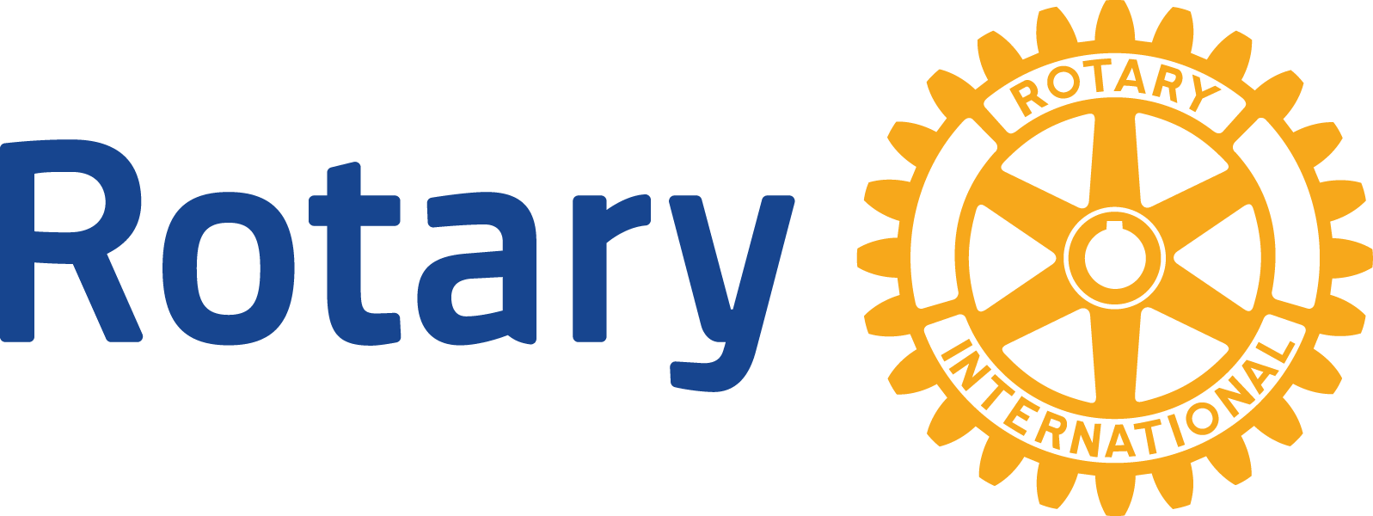
ENGLISH (EN)

GLOBAL GRANTS COMMUNITY ASSESSMENT RESULTS

Use this form to report community assessment findings to The Rotary Foundation when you apply for a global grant.
Assessing the strengths, weaknesses, needs, and assets of the community you plan to help is an essential first step in designing an effective and sustainable global grant project. See Community Assessment Tools for full instructions and helpful tips.
This form will help you report the results of your community assessment, and it’s required when you apply for any humanitarian or vocational training team grant. Complete a separate form for each beneficiary community (e.g., school, health care system, or village), using information that is both current and specific to each community. Remember, you can’t use global grant funds to cover the cost of doing an assessment, but you can use district grant funds.

COMMUNITY OVERVIEW
Describe the characteristics (such as geographic information, main sources of income, population size, and access to education and health services) of the specific community where this project will take place.

COLLECTING COMMUNITY ASSESSMENT DATA
When you conducted the assessment, who in the community did you speak to? At least two different community representatives and beneficiaries who are not involved in Rotary (such as teachers, doctors, or community leaders) should be included in the discussions.

When in the last year did the discussions occur?

What methods did you use to collect information from community members (such as community meetings, interviews, or focus groups)?

TARGET POPULATION
Who will benefit directly from the project? List the groups that will benefit (such as schools, hospitals, vocational training centers, cooperatives, or villages).

Describe the process of how the beneficiaries were identified.

COMMUNITY STRENGTHS, NEEDS, PRIORITIES, AND PROJECT DESIGN
Describe what members of the community said matters to them during the assessment.

Describe the community’s strengths and resources.

Describe any challenges and gaps in the community’s behaviors, skills, and knowledge.

What issues will the project address, and how does the community currently address those issues?

Provide the specific details of the project design and how it will solve these issues.

Describe the long-term plan for the project (such as oversight, financial responsibilities, and expected behavior change) after Rotary’s involvement ends.

ENVIRONMENTAL ASSESSMENT (FOR ALL ENVIRONMENT AND WATER, SANITATION, AND HYGIENE PROJECTS)
What are currently the greatest environmental threats to local land, air, water resources, and the ecosystem?

List any cultural practices that are relevant to the project (such as agricultural techniques or traditions).

What positive and negative environmental changes do you expect to result from the project?

